Mariam Tsirekidze ID: 823460489
In TreeNode.h I have class TreeNode with private data variables: data, Lchild, Rchild. There is also default constructor and constructor of node, setter and getter(I didn’t use setter and getter just because class BST is friend of class TreeNode)
On BST.h I have public and private functions. Public: BST();
void insert(int item);
void deleteItem(int item);
void graph(ostream& out);
bool search( int item);
void preorder(ostream & out );
void postorder(ostream & out);
void inorder(ostream & out);

private:
void inorderAux(ostream& out,TreeNode* subtreePtr) ;
void preorderAux(ostream& out,TreeNode* subtreePtr);
void postorderAux(ostream& out,TreeNode* subtreePtr);
void graphAux(ostream& out, int indent, TreeNode* subtreeRoot);

also there is one private variable: TreeNode* root;

on BST.cpp I have description of every function which was on BST.h

driver.cpp

1)in first case create BST with no value graph it and see that there is no output.

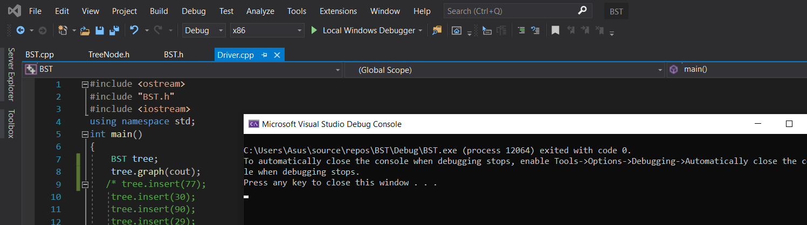

2) I tried to delete node from empty BST

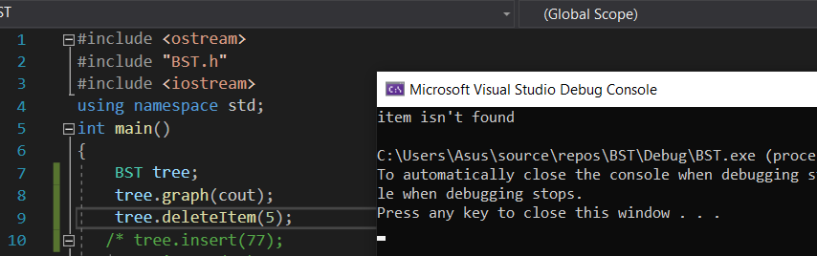
3)I tried to insert some numbers and display it like a BST graph:

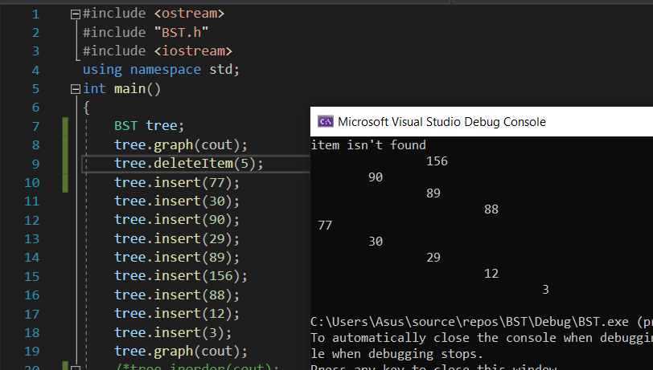
4)then I tried to search non-existing number and then existing number:

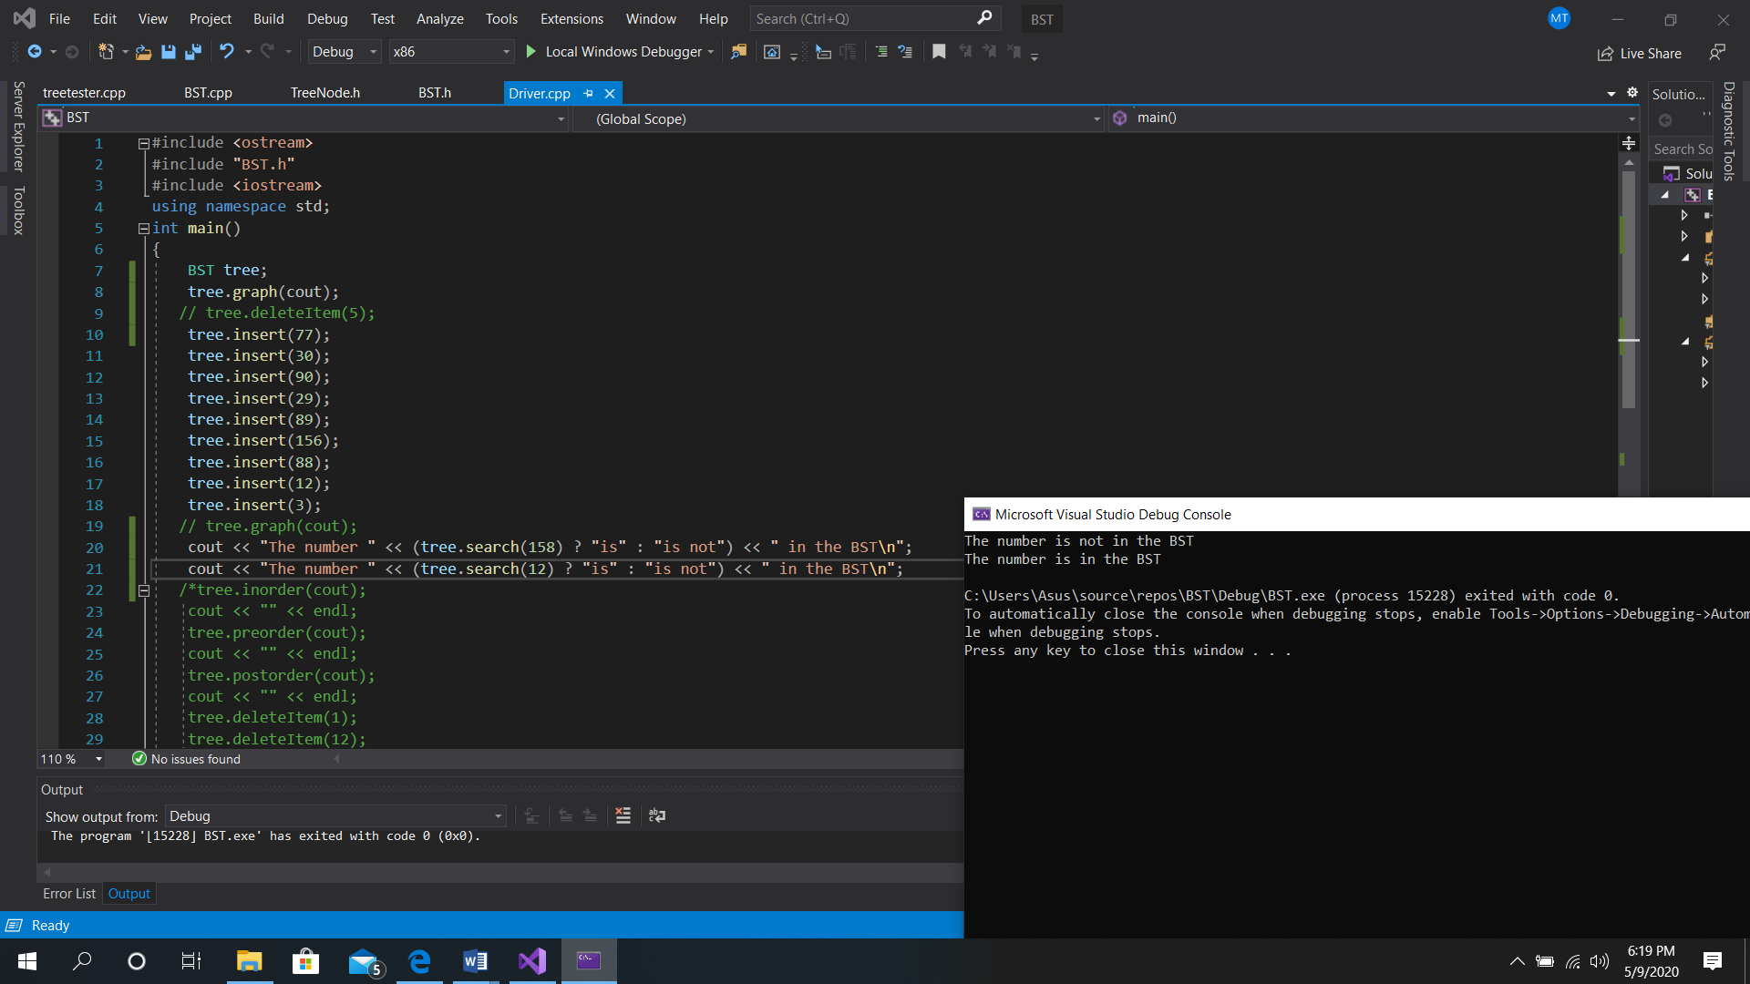

5)the I inorder preorder and postorder the BST:

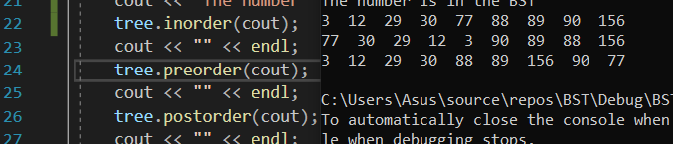
6)delete non-exiting node, then delete node with 1 child, delete node with 2 child and delete node with 0 child.

